NO.1 buggy version

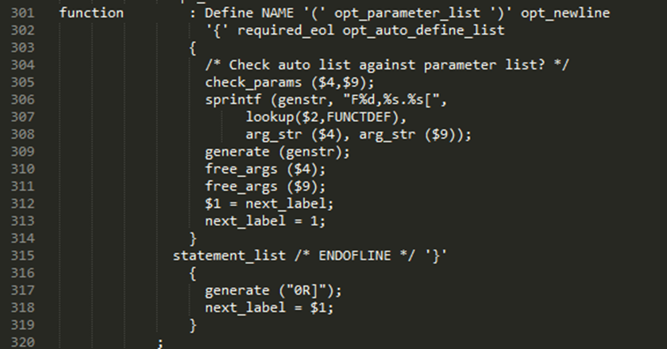

NO.1 fixed version



The first parameter of sprintf is not checked. Use function set_genstr_size to larger the buffer size.

Here is the code of set_genstr_size

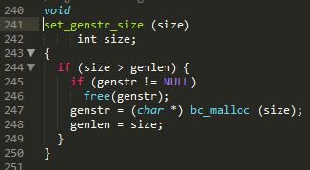

NO.2 buggy version

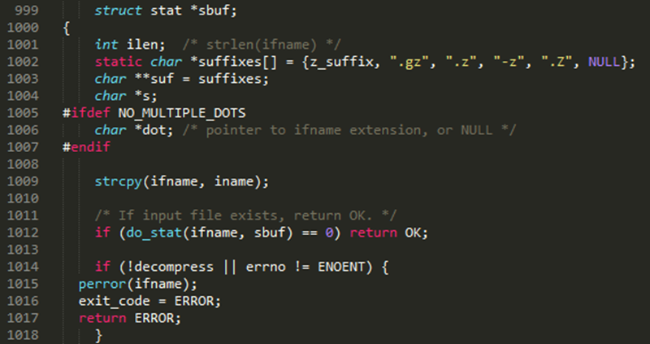

NO.2 fixed version

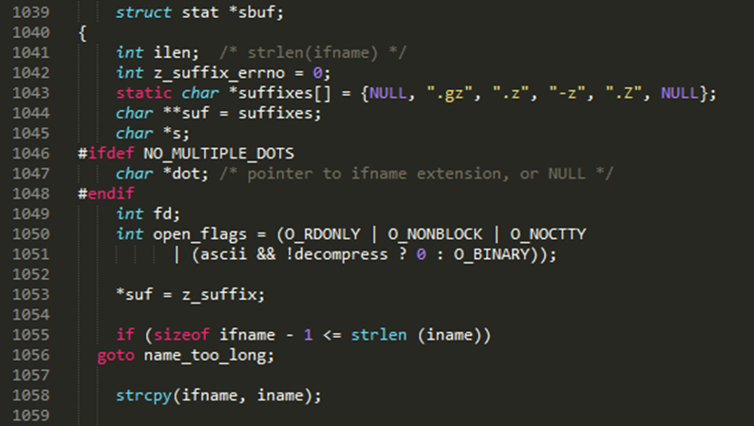

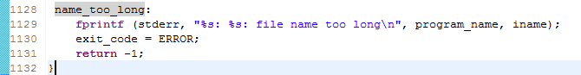

Buffer overflow takes place in strcpy(ifname,iname). ifname is defined as “char ifname[MAX_PATH_LEN]”, and iname is from function get_istat, which is called in function treat_file



Finally, we get the place where treat_file is called:



argv is from function main.

NO.3 buggy version

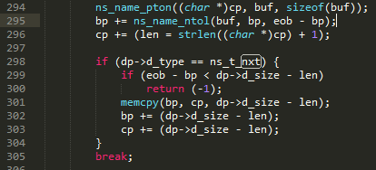

NO.3 fixed version

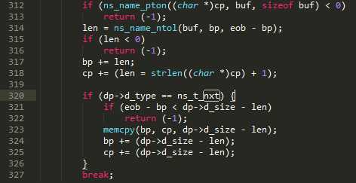

memcpy(bp, cp, dp->d_size - len) leads to a buffer overflow. When ns_name_ntol reports an error, the return value is -1, so bp+=-1. memcpy goes wrong.

NO.5 buggy version

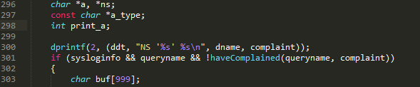

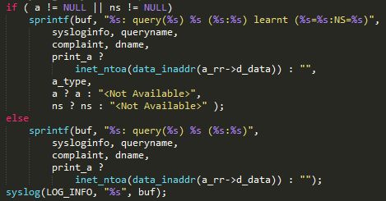

NO.5 fixed version

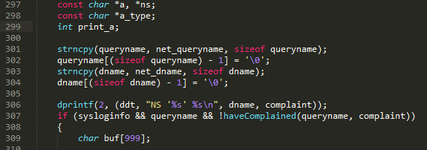

sprintf write queryname into buf, which is defined as “char buf[999]”. A large queryname will cause buffer overflow.

NO.6 buggy version

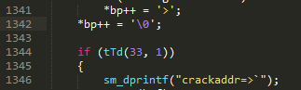

NO.6 fixed version

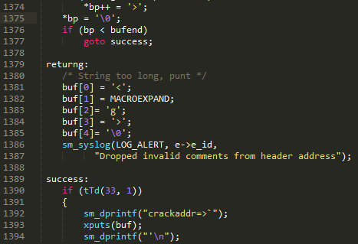

No boundary check for pointer bp causes a buffer overflow.



bp writes into buf once a bit. When bp exceeds bufend, a buffer overflow will happen.

NO.7 buggy version

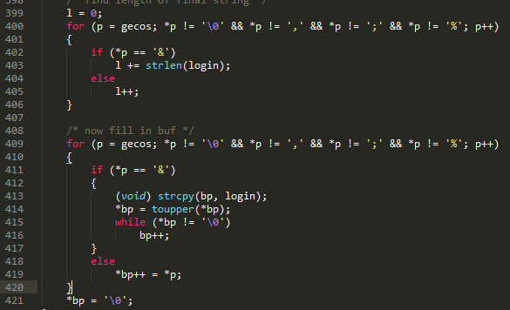

NO.7 fixed version

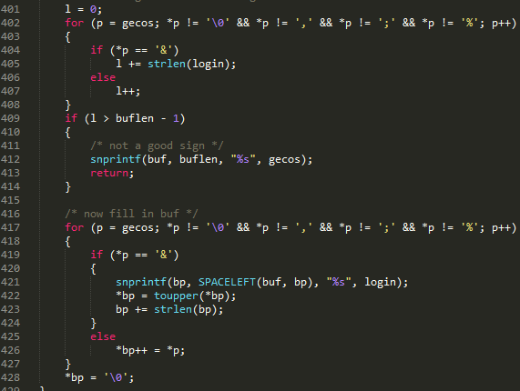

Buffer overflow happens in strcpy, which is caused by a large login.

NO.10 buggy version

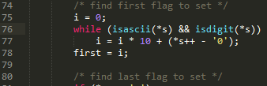



NO.10 fixed version

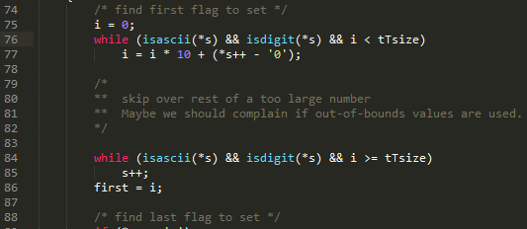

In the buggy version, first can become large due to the while loop. In the fixed version, a boundary check is added.

NO.11 buggy version

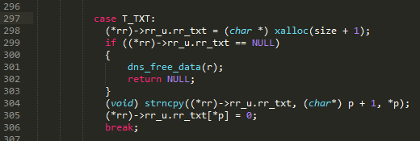

NO.11 fixed version

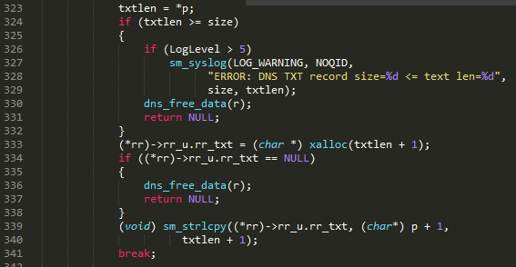

A buffer overflow happens in strncpy((*rr)->rr_u.rr_txt, (char*) p + 1, *p). *p may exceed the size of the first parameter. A boundary check is added in the fixed version.

NO.12 buggy version

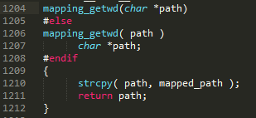



NO.12 fixed version

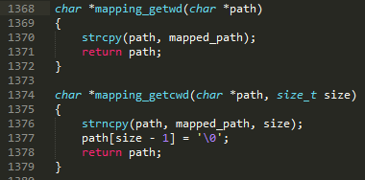



In the buggy version, getcwd is defined as mapping_getwd, which is implemented with strcpy. In the fixed version, it’s changed to strncpy.

NO.14 buggy version

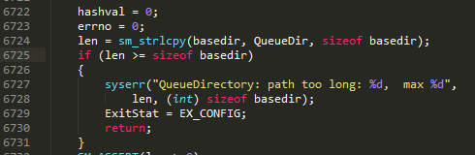



NO.14 fixed version

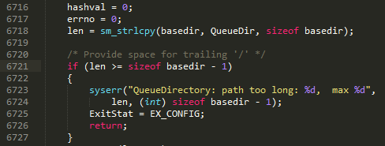

Off-by-one error in boundary check.

NO.15 buggy version

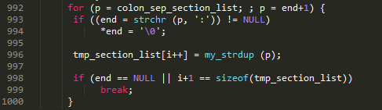

NO.15 fixed version

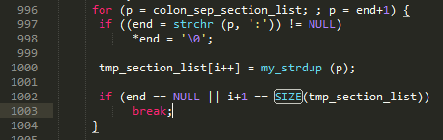



The array tmp_section_list leads to a buffer overflow, which is defined as:



In the for loop, the condition for break is wrong.

NO.16 buggy version



NO.16 fixed version

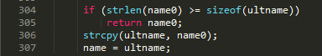

Buffer overflow happens in strcpy(ultname,name0). ultname is defined as:



name0 is an input from user. A large name0 will exceed the size of ultname.

NO.17 buggy version

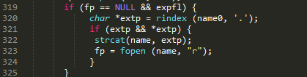

NO.17 fixed version

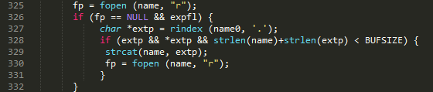

Buffer overflow happens in strcat(name,extp), name is defined as:



extp is defined as:



The function rindex returns a substring of name0 from the last ‘.’ to the end.

No boundary check leads to a overflow.

NO.18 buggy version



NO.18 fixed version





The char array wstr may not end with ‘\0’, so a buffer overflow may happen in sscanf.

NO.19 buggy version

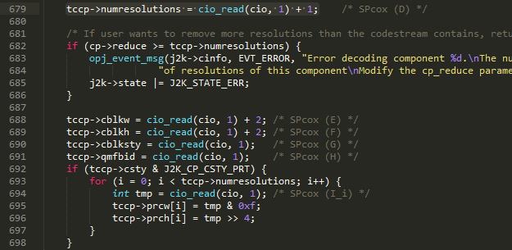

NO.19 fixed version

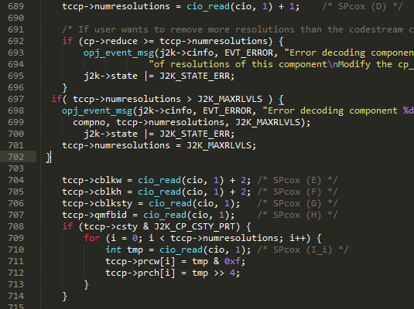

The array tccp->prcw may overflow. In the for loop, the upper bound of i is tccp->numresolutions-1, which get its value from:



The array prcw is defined as



When tccp->numresolutions is greater than J2K_MAXRLVLS, the array will overflow.

NO.20 buggy version



NO.20 fixed version



The array  will overflow due to off-by-one error in the boundary check.

NO.21 buggy version

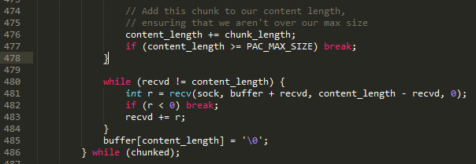

NO.21 fixed version

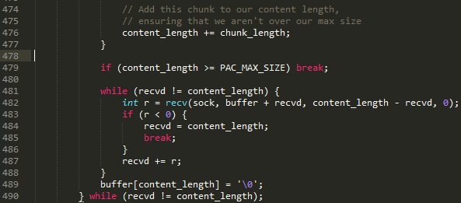

This line: r = recv(sock, buffer + recvd, content_length - recvd, 0) will overflow. The position of boundary check is not right.

NO.27 buggy version



NO.27 fixed version



sp is a variable of type char*. When *sp=0, i.e., it reaches the string end, the sp++ should not be executed.

NO.30 buggy version



NO.30 fixed version

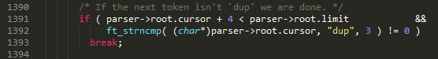

ft_strncmp is the same as strncmp, which is used to compare two strings. Here n equals 3, so the parser->root.cursor will read 3 more bits, which may cause a buffer overflow.

NO.31 buggy version

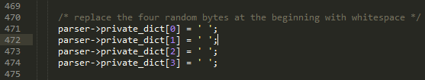

NO.31 fixed version

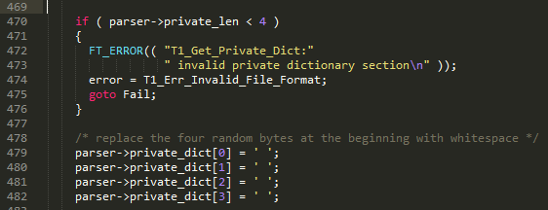

The array private_dict’s size needs to be at least 4.

NO.32 buggy version

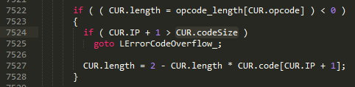

NO.32 fixed version

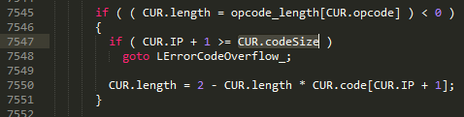

An off-by-one error in boundary check.

NO.33 buggy version

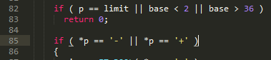

NO.33 fixed version

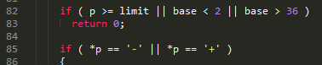

The boundary check in buggy version uses p==limit. However, p gets its value from outside and it may be greater than limit in the first place.

NO.34 buggy version

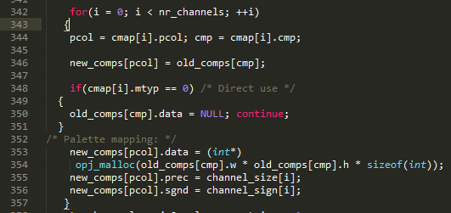

NO.34 fixed version

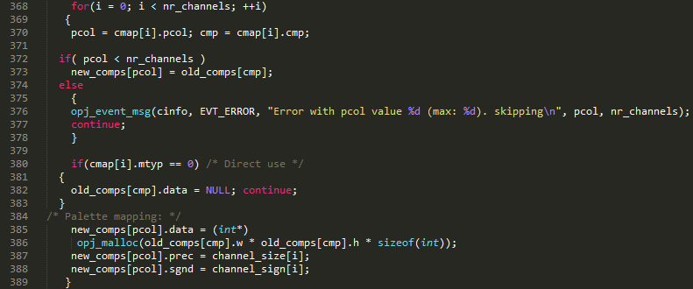

The array new_comps gets its memory from:



So it is obvious the size of this array is nr_channels. In the fixed version, the index pcol is checked to make sure it’s smaller than nr_channels.

NO.35 buggy version

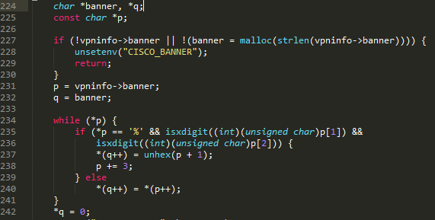

NO.35 fixed version

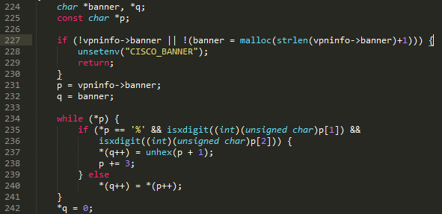

Allocate more memory to banner

NO.38 buggy version



NO.38 fixed version



name+len may exceed the range of name

NO.39 buggy version

in line 852:

strlen_buf = snprintf(output_buf, MAX_BUF, "%.*s%.*s" ERROR_URL "%.*s%s" REJECT_CRLF, STRLEN_REJECT_SEVERITY, (substitute_reject_severity == NULL) ? target_rejection->reject_severity : substitute_reject_severity, target_rejection->strlen_reject_message, target_rejection->reject_message, current_settings->current_options->strlen_policy_location, current_settings->current_options->policy_location, target_rejection->short_reject_message);

NO.39 fixed version

in line 852:

snprintf(output_buf, MAX_BUF, "%.*s%.*s" ERROR_URL "%.*s%s" REJECT_CRLF "%n", STRLEN_REJECT_SEVERITY, (substitute_reject_severity == NULL) ? target_rejection->reject_severity : substitute_reject_severity, target_rejection->strlen_reject_message, target_rejection->reject_message, current_settings->current_options->strlen_policy_location, current_settings->current_options->policy_location, target_rejection->short_reject_message, &strlen_buf);

Using the return value of snprintf as the size of bits written into output_buf is not right. Use “%n” instead.

NO.40 buggy version

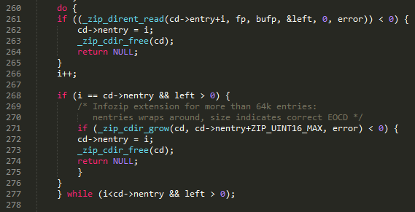

NO.40 fixed version

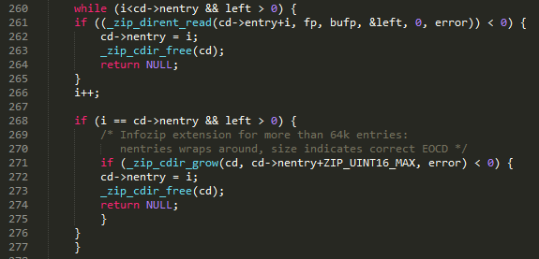

The use of do...while loop is not right, because it will execute the code once before checking the condition of while.

NO.41 buggy version

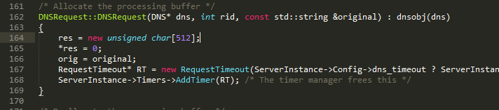



NO.41 fixed version

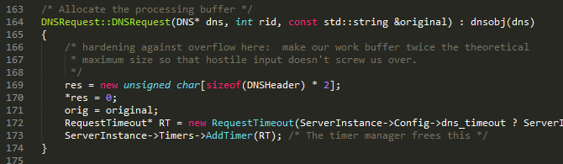

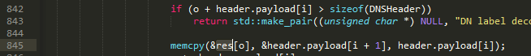

Buffer overflow happens in memcpy. A boundary check is needed. In addition, they make the buffer twice the theoretical maximum size.

NO.43 buggy version

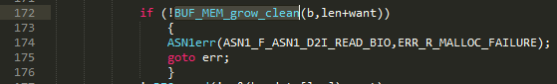

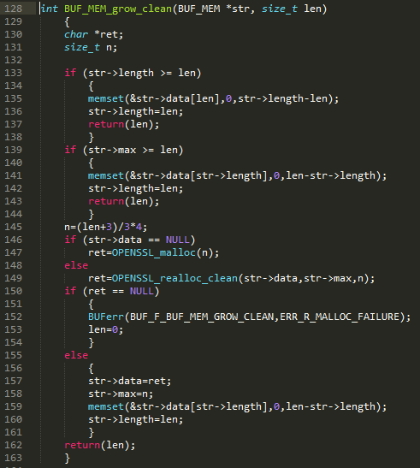

NO.43 fixed version

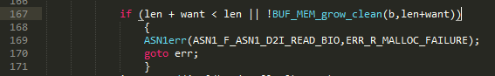

Integer overflow of len+want leads to a buffer overflow in memset in BUF_MEM_grow_clean

NO.45 buggy version

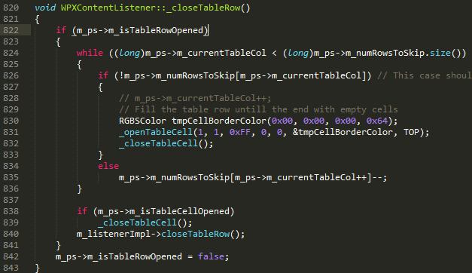

NO.45 fixed version

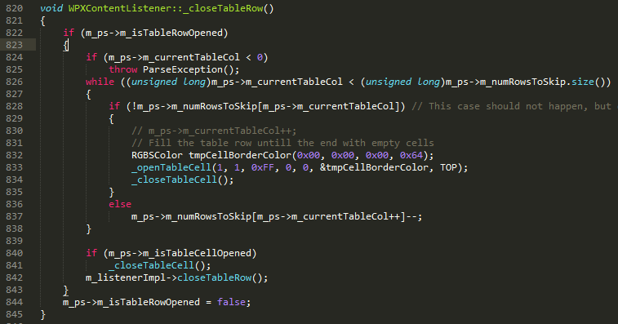

The array m_ps->m_numRowsToSkip needs a boundary check.

NO.47 buggy version





NO.47 fixed version







The function memcpy may overflow. The function g_strndup from glib ensures the overflow won’t happen.

NO.48 buggy version



NO.48 fixed version

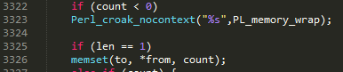

The function memset’s third parameter needs to be positive.

NO.49 buggy version

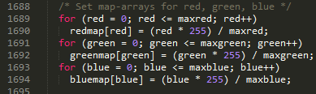

NO. 49 fixed version

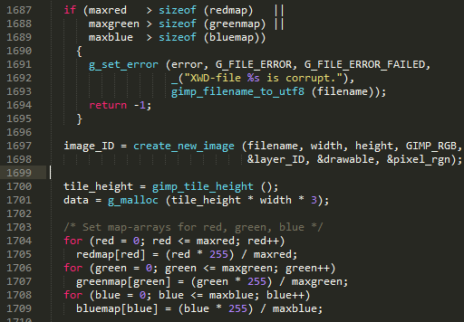

The access to the array redmap in the for loop needs a boundary check.

NO.51 buggy version

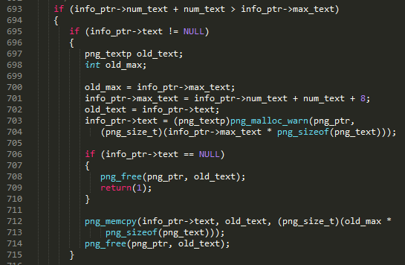

NO.51 fixed version

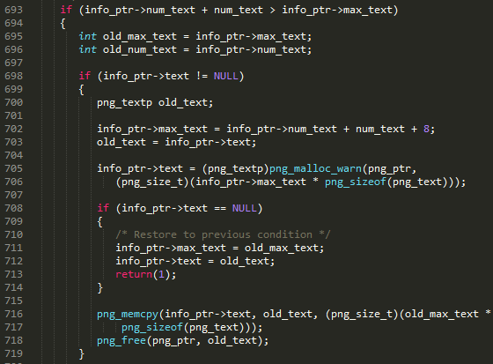

If the malloc fails, info_ptr->text should be restored to previous value. The buggy version ignores this, so in the following picture a buffer overflow will happen.

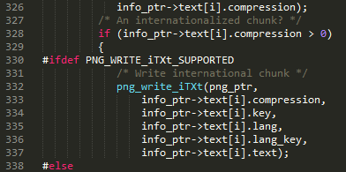

NO.52 buggy version

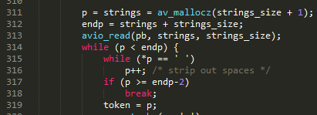

NO.52 fixed version

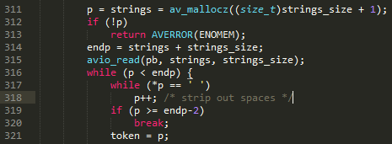

If malloc fails, p will be null. A overflow happens when assigning a value to *p.

NO.53 buggy version





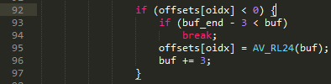

NO.53 fixed version





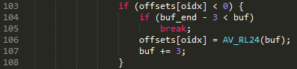

The value oidx may be 7. A large buffer is needed.

NO.54 buggy version

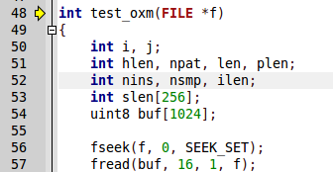

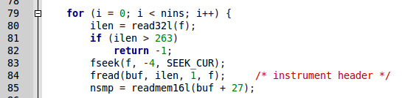

NO.54 fixed version

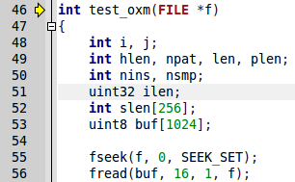

Setting the value of ilen to a negative number will bypass the boundary check.

NO.55 buggy version

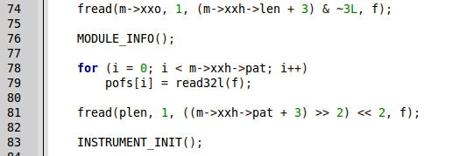

NO.55 fixed version

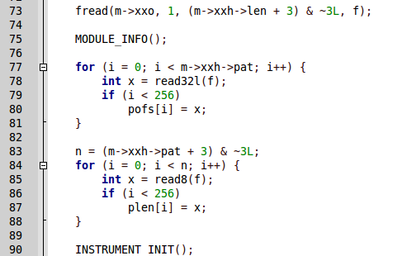

The array pofs needs a boundary check.

NO.56 buggy version

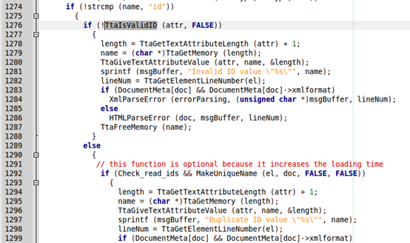

NO.56 fixed version

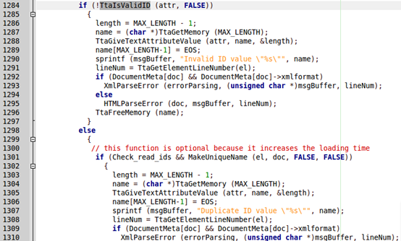

The function sprintf will not stop copying bits from name to msgBuffer until it reads a ‘\0’. A ‘\0’ is added to name.

NO.57 buggy version

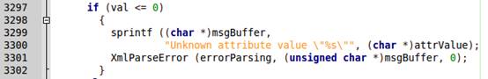

NO.57 fixed version

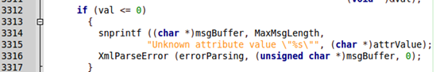

The length of attrValue may exceed the size of msgBuffer.

NO.58 buggy version

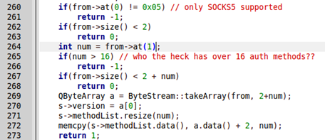

NO.58 fixed version

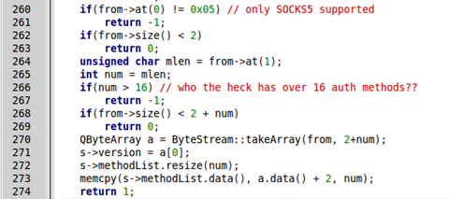

A negative number will bypass the boundary check.

NO.59 buggy version

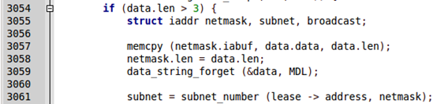

NO.59 fixed version

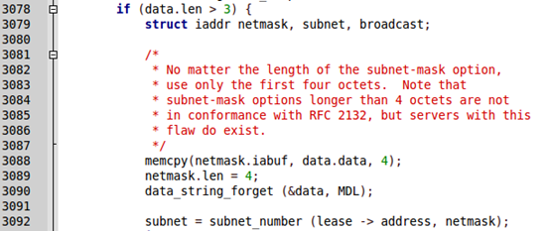

A large data.len leads to a buffer overflow in memcpy. Setting the value to 4 can fix it.

NO.61 buggy version





NO.61 fixed version





A large imagepath or name may lead to a buffer overflow in sprintf.

NO.62 buggy version

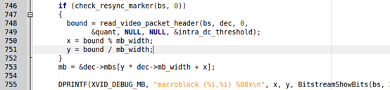

NO.62 fixed version

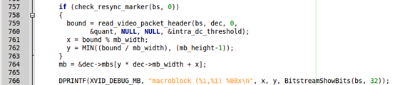

The value of y may cause an overflow.

NO.64 buggy version



NO.64 fixed version



The function sprintf may cause a buffer overflow. Use snprintf instead.

NO.65 buggy version

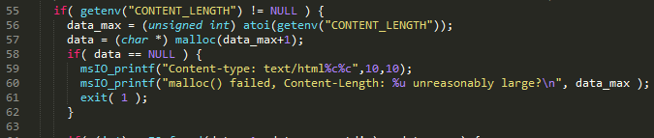



NO.65 fixed version

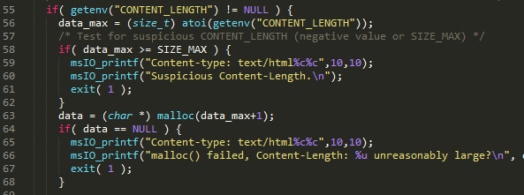



The parameter of the function malloc needs to be checked.

NO.66 buggy version

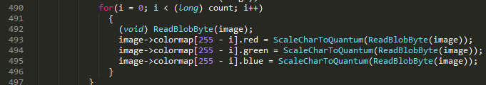

NO.66 fixed version

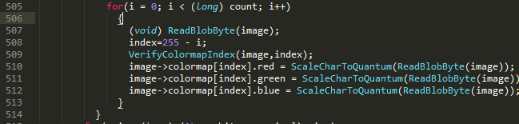

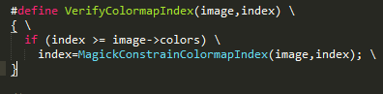

The array image->colormap may cause a buffer overflow.

NO.68 buggy version

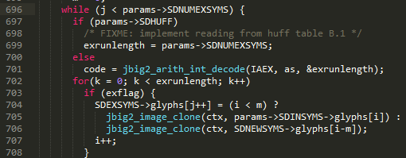

NO.68 fixed version

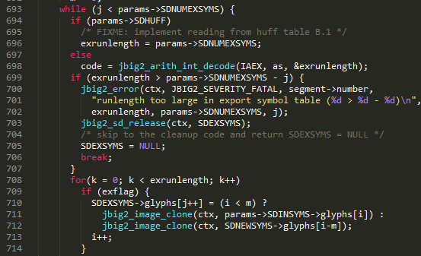

The index of SDEXSYMS->glyphs may reach to j+exrunlength-1. So a large exrunlength may cause a buffer overflow.

NO.69 buggy version

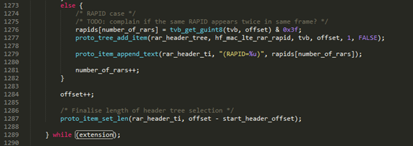



NO.69 fixed version

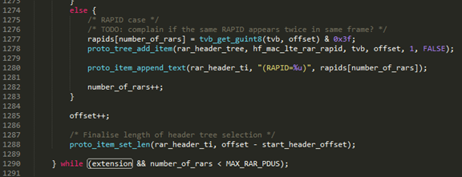



The array rapids may cause a buffer overflow.

NO.70 buggy version

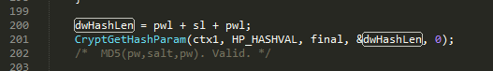

NO.70 fixed version



In different system, dwHashLen in the buggy version will get different value, which may cause a buffer overflow.

NO.71 buggy version

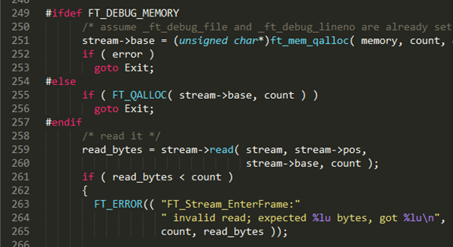

NO.71 fixed version

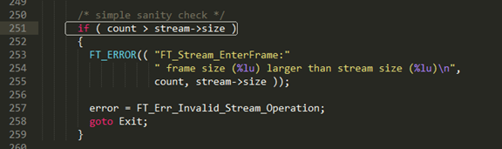

In the buggy version, if counter is larger than the size of stream, an overflow will happen. Check the value to prevent this.

NO.72 buggy version



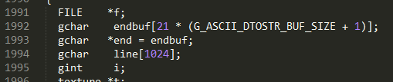

NO.72 fixed version

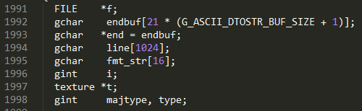





If the value of G_ASCII_DTOSTR_BUF_SIZE is relatively small, a buffer overflow will happen in sscanf.

NO.74 buggy version

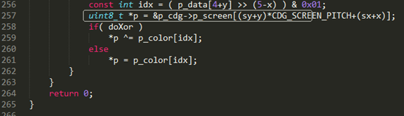

NO.74 fixed version

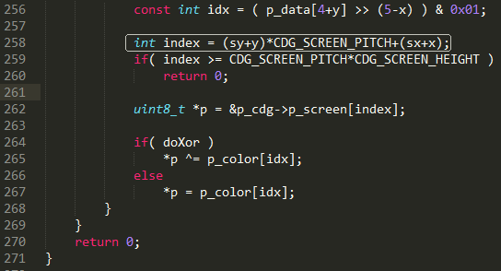

The array p_screen may cause an overflow.

NO.75 buggy version

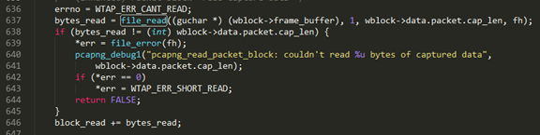

NO.75 fixed version

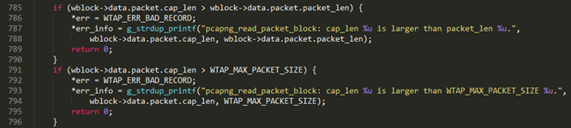

If cap_len is larger than the size of buffer, a buffer overflow will happen.

NO.76 buggy version

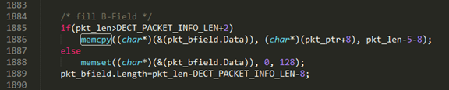

NO.76 fixed version

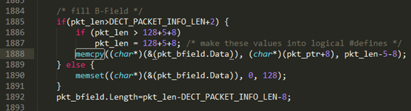

The function memcpy needs boundary check.

NO.78 buggy version

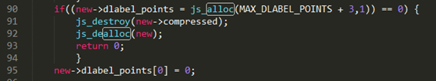

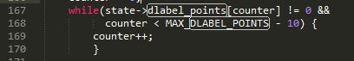

NO.78 fixed version

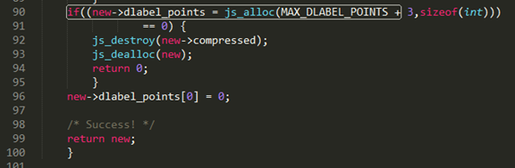

Not enough memory is allocated to dlabel_points, which causes a buffer overflow in the while loop.

NO.79 buggy version

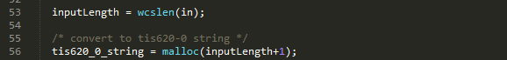

NO.79 fixed version

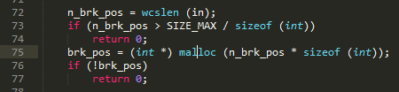

The function malloc’s parameter and return value need to be checked.

NO.80 buggy version

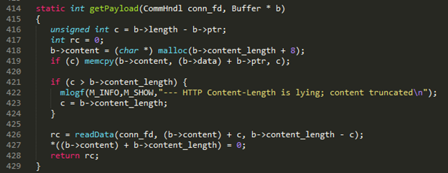

NO.80 fixed version

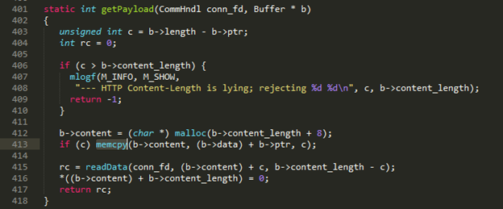

If the length of data(b->content_length) is too short, a buffer overflow will happen in memcpy.

NO.81 buggy version

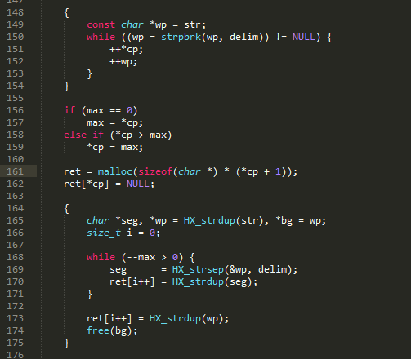

NO.81 fixed version

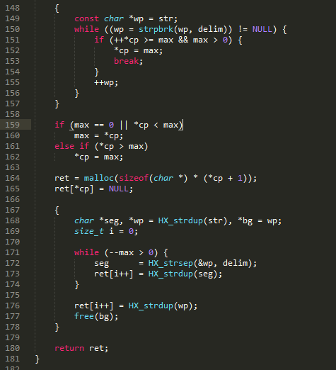

In the buggy version, the while loop in line 150 may end with *cp<max. In line 161, ret is allocated memory with size *cp+1 and line 170 will write max values into ret. This may lead to a buffer overflow.

NO.82 buggy version

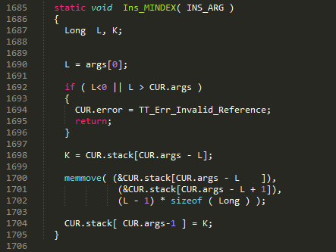

NO.82 fixed version

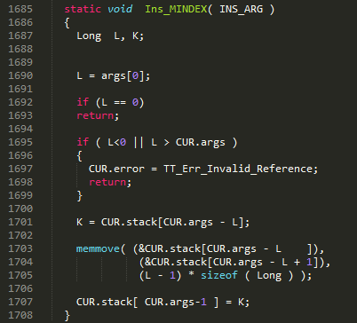

The function memmove may cause an overflow when L=0.

NO.83 buggy version

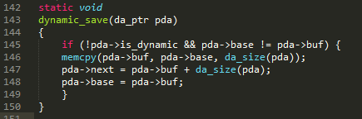

NO.83 fixed version

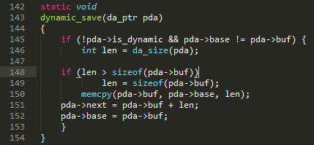

The function memcpy may overflow if da_size(pda) is larger than the size of pda->buf.

NO.84 buggy version

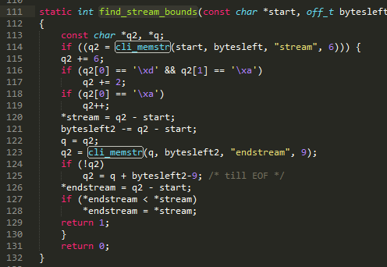

NO.84 fixed version

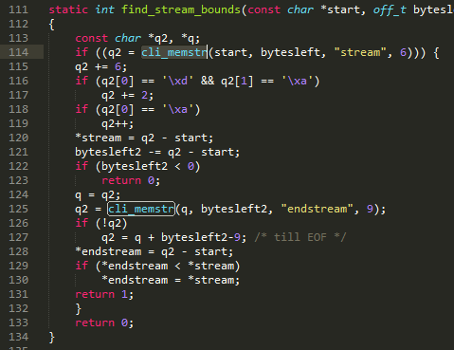

When the variable byteleft2 becomes negative, it will become a large positive number, which may cause an overflow in cli_memstr. The API array is involved in this function.

NO.85 buggy version



NO.85 fixed version

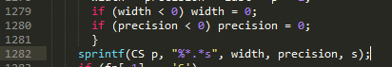

When width and precision is negative, they will turn into large positive numbers. An overflow will happen.

NO.87 buggy version

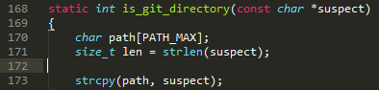

NO.87 fixed version

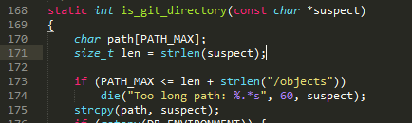

The function strcpy needs a boundary check.

NO.88 buggy version

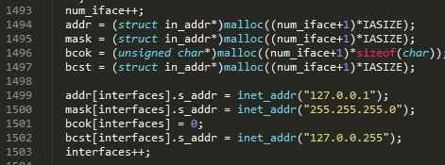

NO.88 fixed version

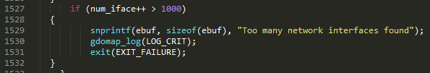

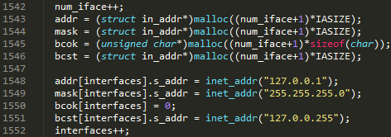

If num_iface is too large, malloc will fail. The following array access may cause an overflow.

NO.89 buggy version







NO.89 fixed version



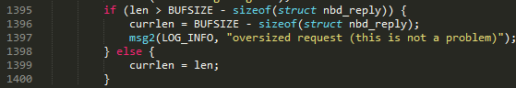

The function readit is implemented as:

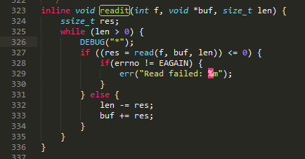

When len is not right, a buffer overflow may happen.

NO.90 buggy version

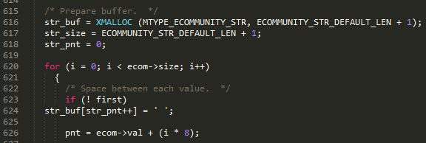

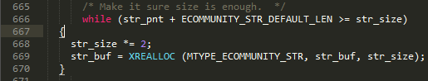

NO.90 fixed version

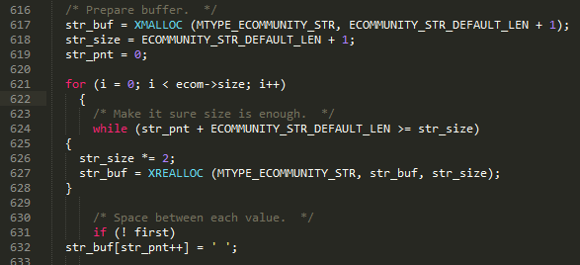

The position of the boundary check is not right.

NO.91 buggy verson

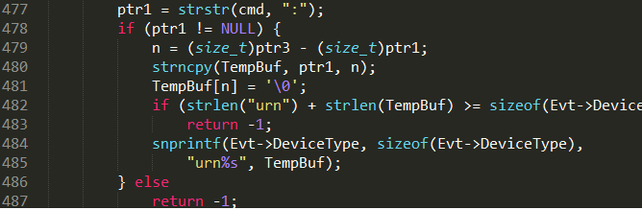

NO.91 fixed version

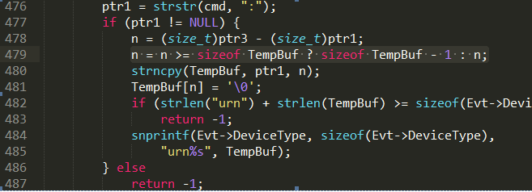

The function strncpy needs a boundary check.

NO.92 buggy version

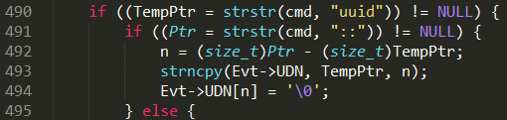

NO.92 fixed version

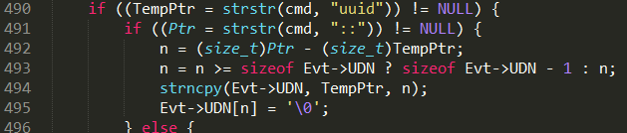

The function strncpy needs a boundary check.

NO.93 buggy version

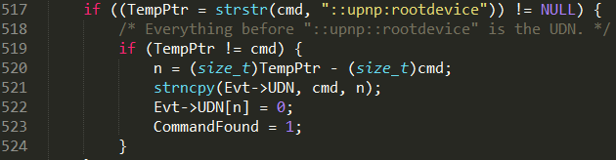

NO.93 fixed version

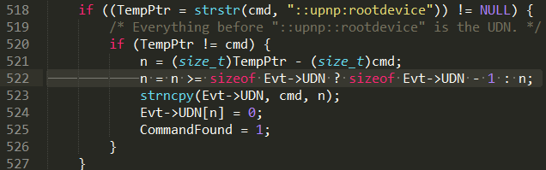

The function strncpy needs a boundary check.

NO.94 buggy version

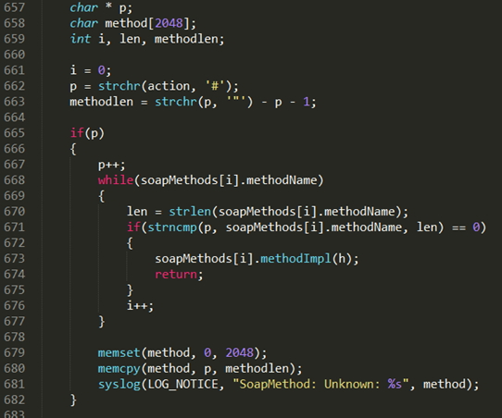

NO.94 fixed version

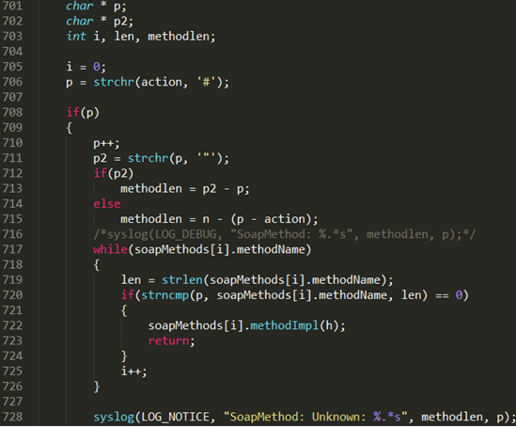

In the buggy version, if the function strchr in line 663 returns a null, methodlen will be negative. In memcpy, it will become a large positive number. In the fixed version, they change the implementation to ensure methodlen is not negative.

NO.95 buggy version

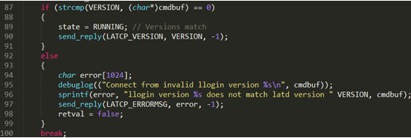

NO.95 fixed version

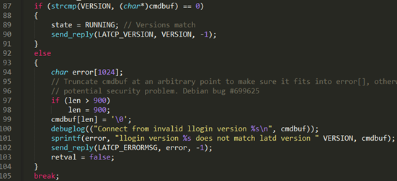

The parameter cmdbuf may cause a buffer overflow in the function sprintf.

NO.96 buggy version



NO.96 fixed version

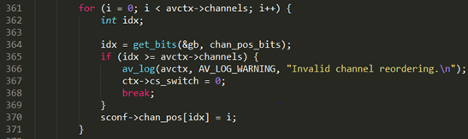

The array chan_pos needs a boundary check to prevent the buffer overflow.

NO.97 buggy version

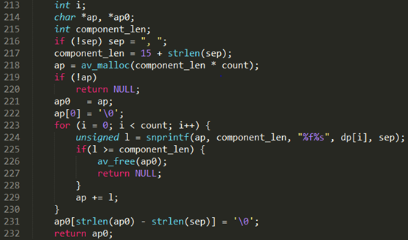

NO.97 fixed version

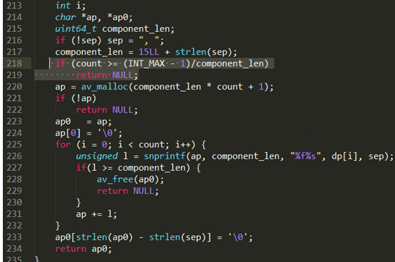

Not enough memory is allocated to ap.

NO.98 buggy version



NO.98 fixed version



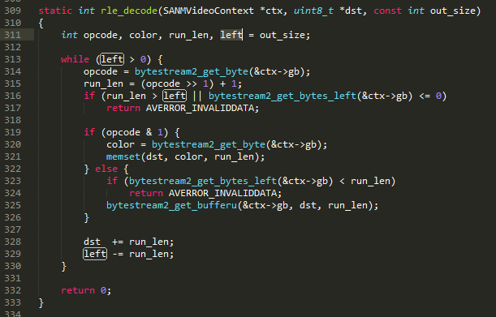

In the buggy version, the function memset in the function rle_decode may cause a buffer overflow.

NO.99 buggy version

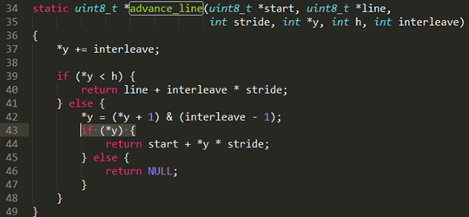

NO.99 fixed version

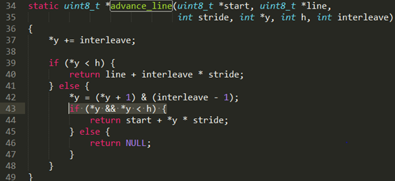

If the value of *y is too large, the return value may cause an overflow.

NO.101 buggy version





NO.101 fixed version



The function sprintf may cause a buffer overflow.

NO.102 buggy version



NO.102 fixed version

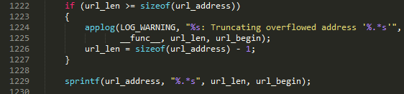

The function sprintf needs a boundary check to prevent the buffer overflow.

NO.103 buggy version

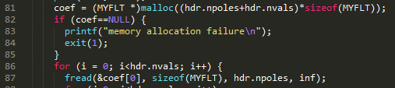

NO.103 fixed version

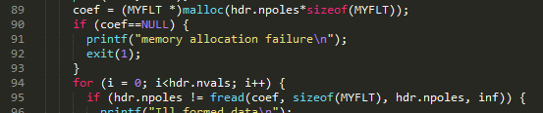

Using smaller parameter can prevent integer overflow in malloc, which may cause an overflow in the function fread.

NO.104 buggy version

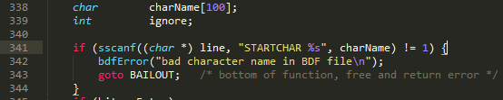

NO.104 fixed version

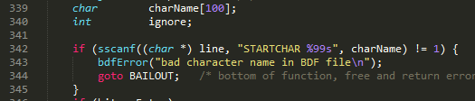

A buffer overflow happens in the function sscanf.

NO.105 buggy version

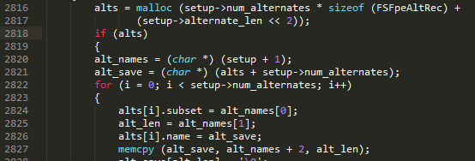

NO.105 fixed version

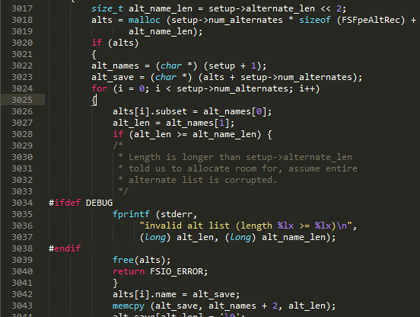

The function memcpy needs a boundary check to prevent the buffer overflow.

NO.106 buggy version



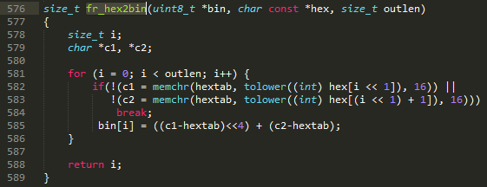

NO.106 fixed version



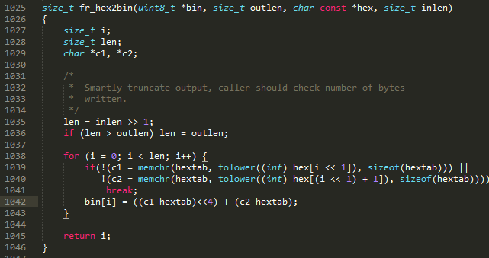

The array bin may cause a buffer overflow.

NO.107 buggy version

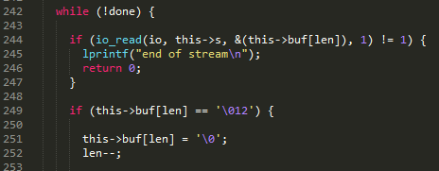

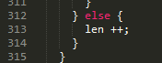

NO.107 fixed version

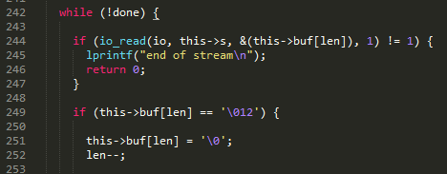

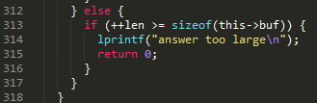

The array buf needs a boundary check to prevent the buffer overflow.

NO.108 buggy version



NO.108 fixed version

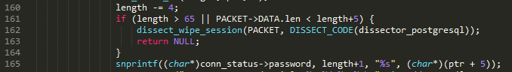

The function strncpy needs a boundary check.

NO.109 buggy version

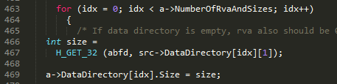

NO.109 fixed version

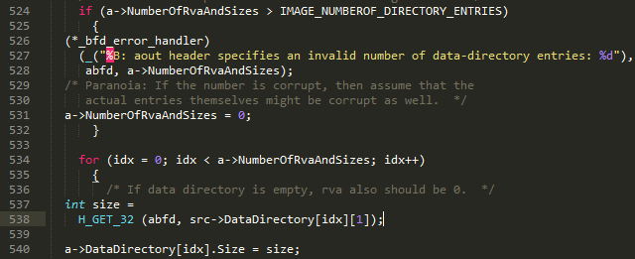



The array DataDirectory needs a boundary check.

NO.110 buggy version

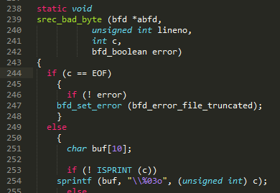





NO.110 fixed version

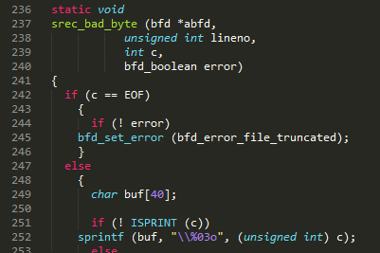





Using a larger buffer for the buffer buf can prevent the buffer overflow.

NO.111 buggy version



NO.111 fixed version

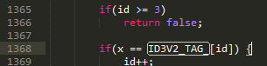

The buffer overflow happens in the array ID3V2_TAG_, which is defined as



NO.112 buggy version

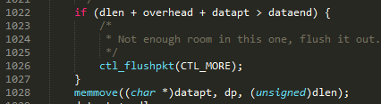

NO.112 fixed version

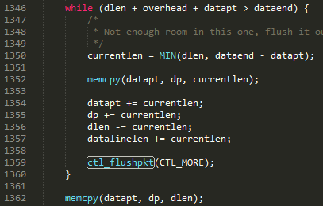

Replacing if with while can ensure the function memmove won’t overflow.

NO.113 buggy version



NO.113 fixed version

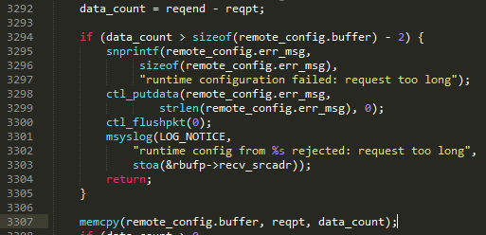

The function memcpy needs a boundary check.

NO.114 buggy version



NO.114 fixed version

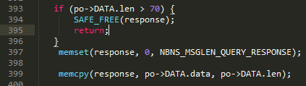

The function memcpy needs a boundary check.

NO.115 buggy version



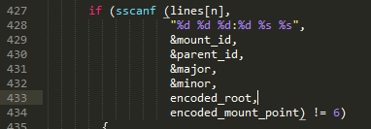

NO.115 fixed version





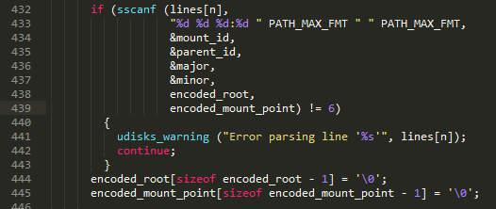

A buffer overflow happens in the function sscanf.

NO.116 buggy version





NO.116 fixed version





Substituting snprintf for sprintf to prevent a buffer overflow.

NO.117 buggy version

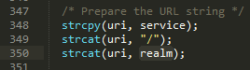

NO.117 fixed version



A buffer overflow happens in the function strcat.

NO.118 buggy version







NO.118 fixed version

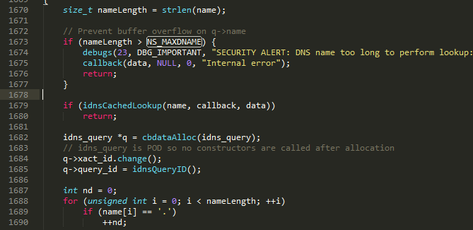



The function strcpy needs a boundary check.

NO.119 buggy version





NO.119 fixed version





Substituting snprintf for sprintf to prevent a buffer overflow.

NO.120 buggy version

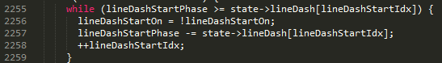

NO.120 fixed version



The array lineDash needs a boundary check.

NO.121 buggy version



NO.121 fixed version



Using the function min to prevent the buffer overflow in memcpy.

NO.122 buggy version

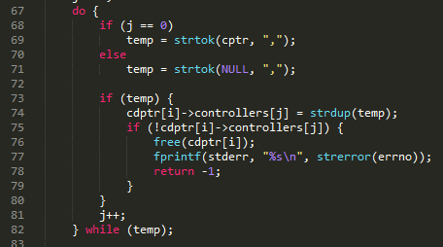

NO.122 fixed version

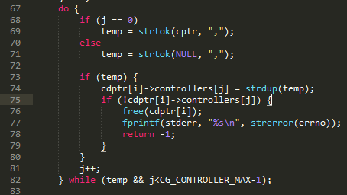

A buffer overflow happens in the array controllers.

NO.123 buggy version



NO.123 fixed version

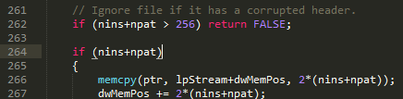

The function memcpy needs a boundary check to prevent a buffer overflow.